**DATA SCIENCE CAPSTONE PROJECT - HEALTHCARE**

Hi,

Good Day!

Below is HTML & IPYNB files of the project, further below you can find the LINK & Screen Shots for the WEEK 4 project - Tableau Data Reporting.

 

**LINK:**

**<https://public.tableau.com/views/CapstoneProject_16217810434530/DonutPiechart?:language=en&:display_count=y&:origin=viz_share_link>**

**Screen Shots:**

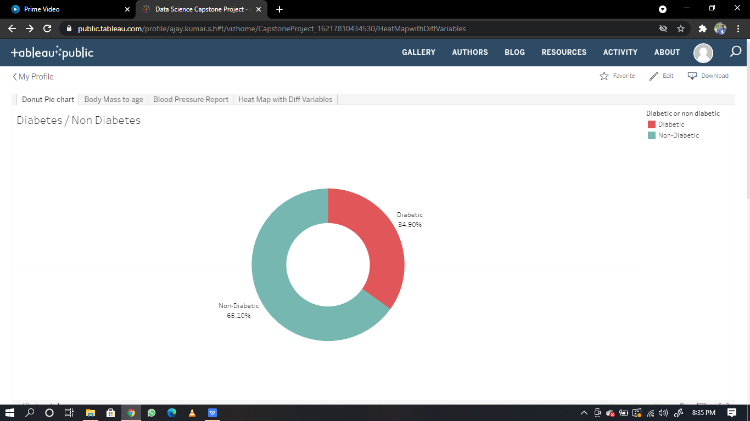

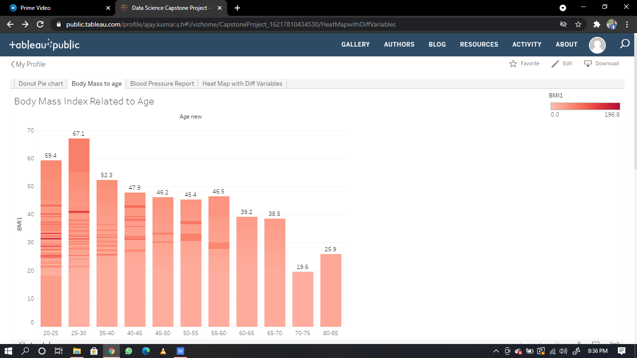

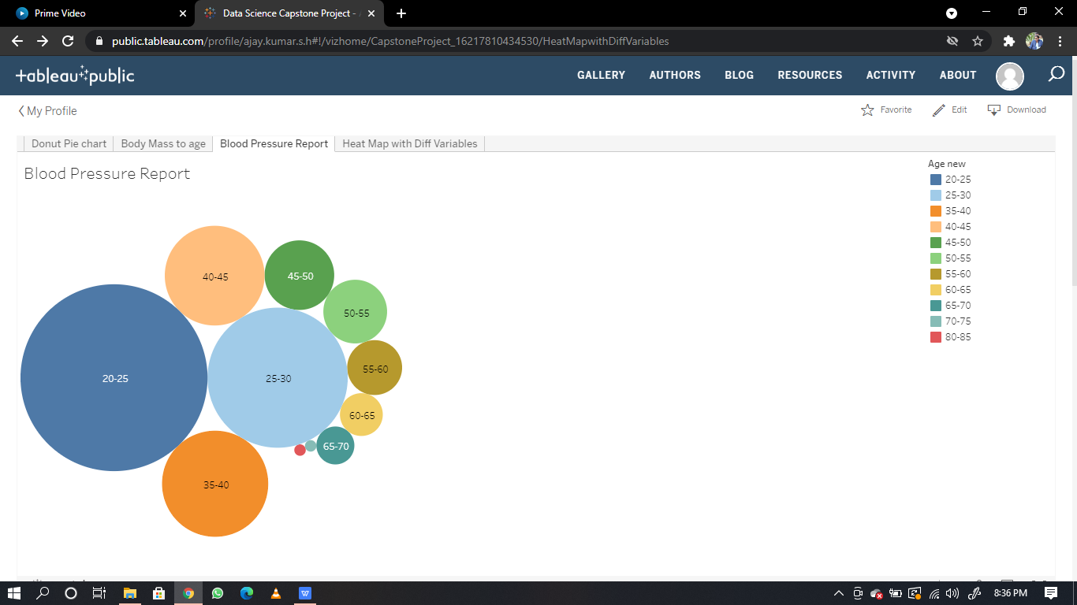

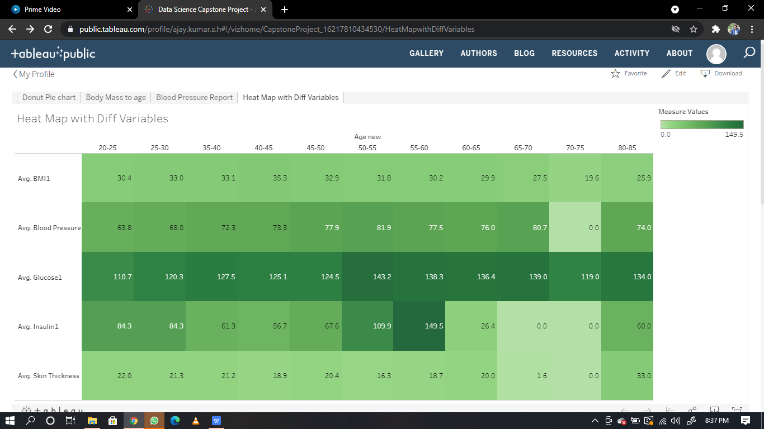

**THANK YOU!!**